















|  |  |
| --- | --- |
|  |  |
|  |  |
|  |  |
|  |  |
|  |  |
|  |  |
|  |  |
|  |  |

|  |  |
| --- | --- |
|  |  |
|  |  |
|  |  |
|  |  |
|  |  |
|  |  |
|  |  |
|  |  |
|  |  |
|  |  |
|  |  |
|  |  |
|  |  |
|  |  |
|  |  |
|  |  |
|  |  |
|  |  |
|  |  |

|  |  |
| --- | --- |
|  |  |
|  |  |





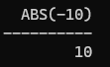







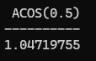

















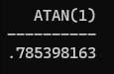 









DONE













DONE





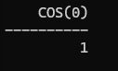













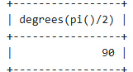



























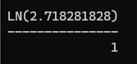



















DONE



DONE













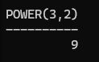





  

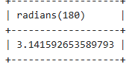

























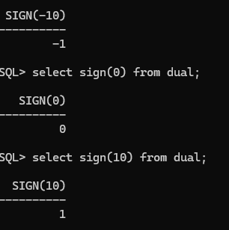











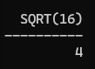















DONE











      
      
      
      
      